Qualtrics: Rubik’s Cube Simulator Documentation

# Default Values for Shuffling and Choosing the Step to Solve

1. Visit - [WCA Official Cube scrambler (rubikscube.info)](http://rubikscube.info/pravidla/scrambles/scramble_cube.htm) and copy the sequence that you generate.

2. In the EXPERIMENTERS ONLY question, click on the Default Choices button on the top right.

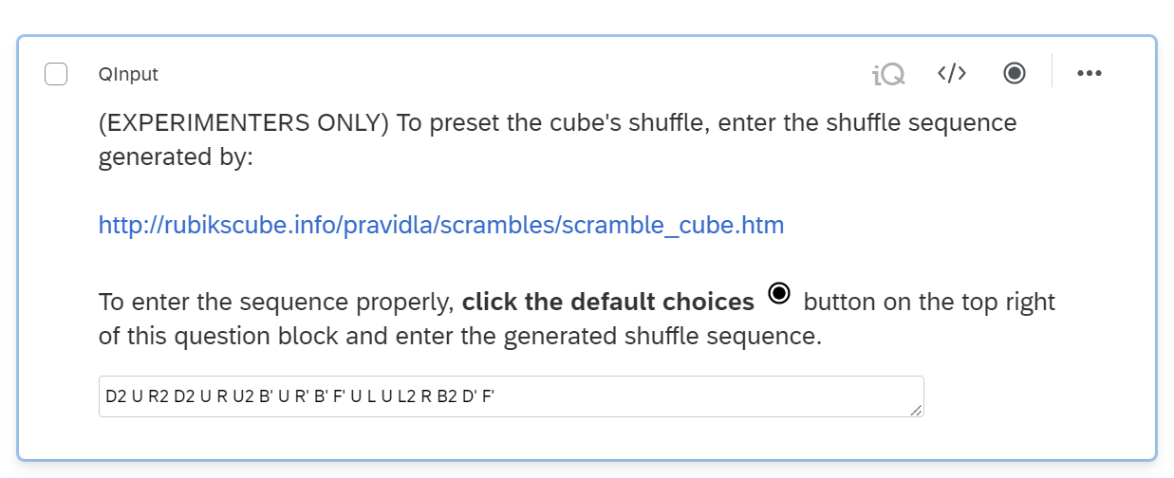

3. Once the “Edit Default Choices” pop-up appears, then paste the text into the textbox and click on the green Save button.

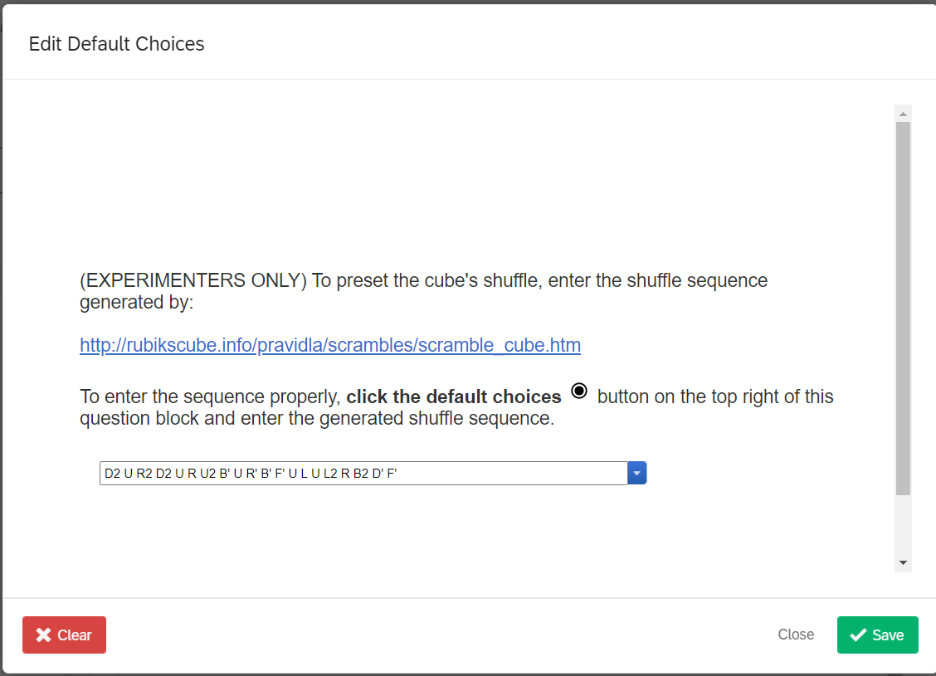

1B. The other EXPERIMENTERS ONLY question with the chosen step to solve follows the same process as above, except there is no external link to pull data from. You just need to select with step to solve and save it like normal.

# Look and feel for CSS (New Survey)

The CSS deals with the styling of the survey, or in our case the styling of the cube. To copy the CSS over follow these steps

1. 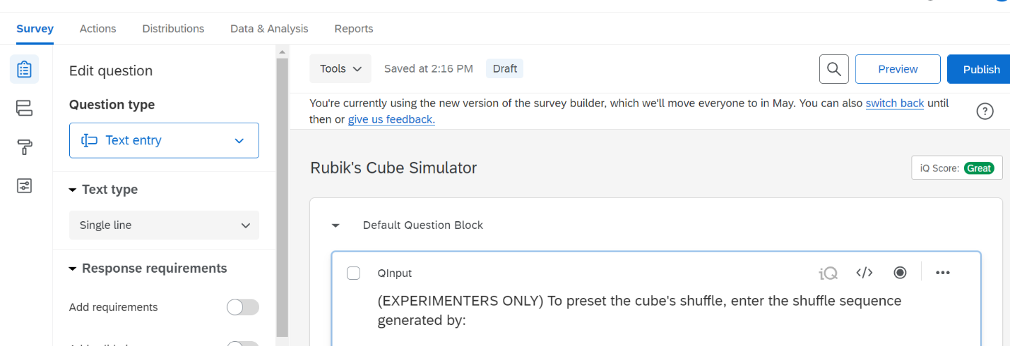Make sure you are under the “Survey” tab and select “Look & Feel”
2. 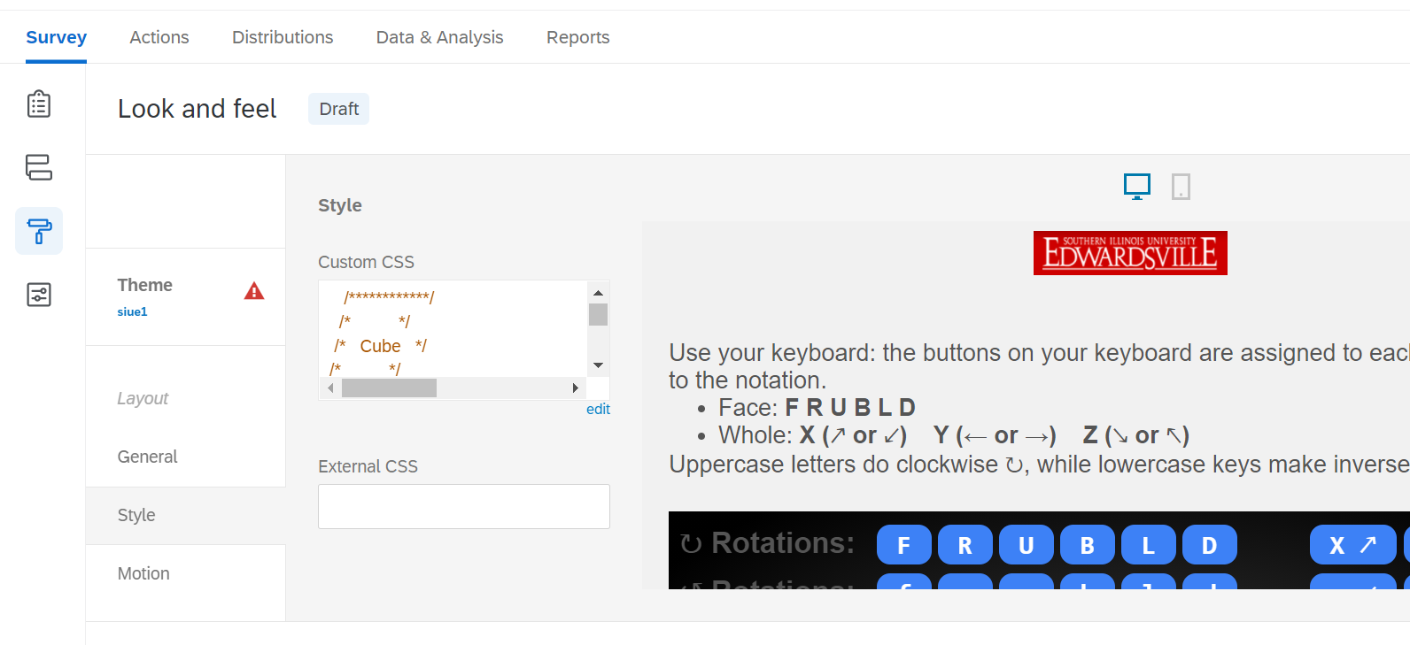Select the “Style” tab and from there click on the text inside the Custom CSS textbox. Since the text is too much to simply highlight the entire code by dragging the mouse, enter CTRL + A to highlight all the text within the textbox at once, then copy the text.

Click inside the textbox here, then enter CTRL+A to select all the code, followed by CTRL+C to copy

3. Once the text is copied, switch to the new survey that has yet to receive the CSS, go to the same Custom CSS textbox on there, and paste it in.

4. After you finished editing the CSS make sure you save the survey.

# Import Questions (Entire block)

1. Select “Import From Library”

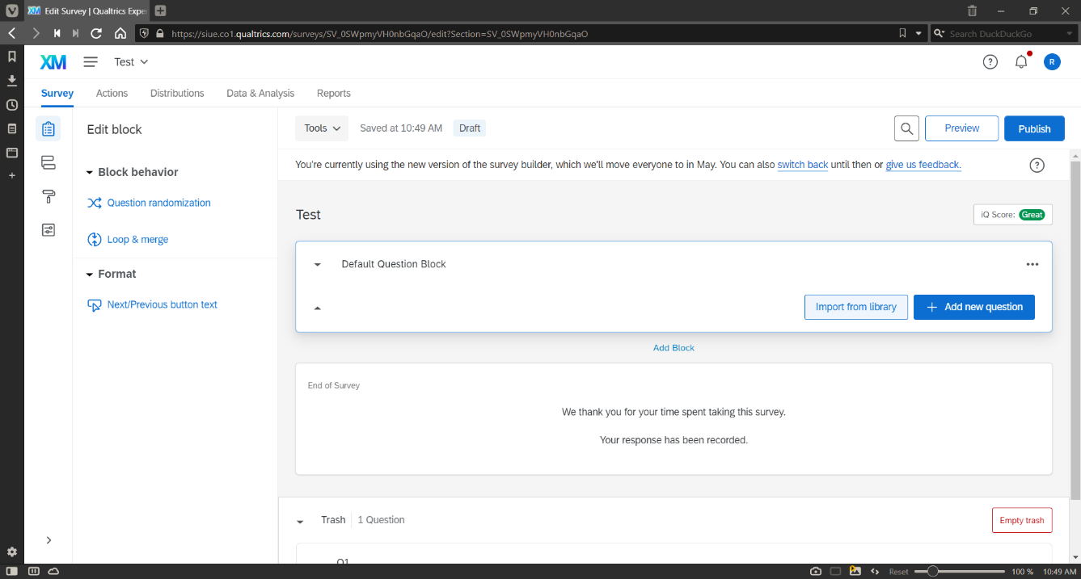

2. Select the library containing your survey that you would like to import.

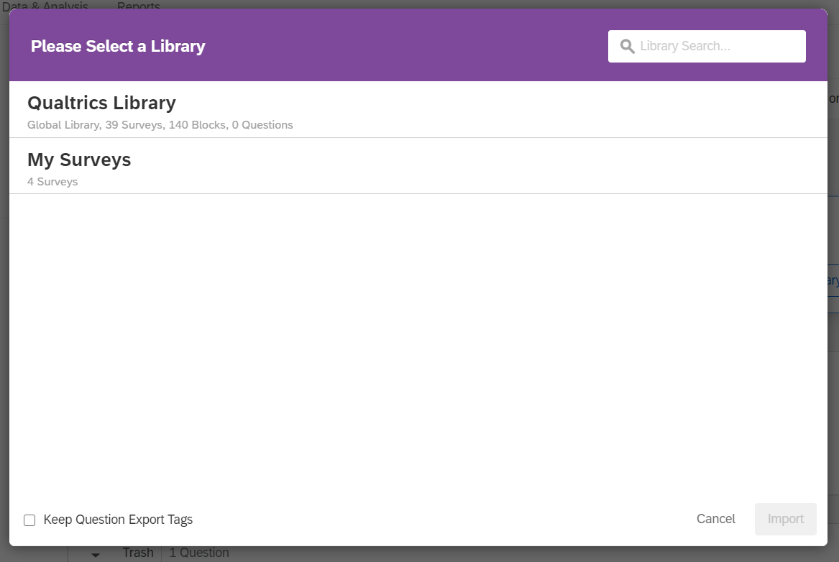

3. Select the survey that contains the question(s) that you would like to import.

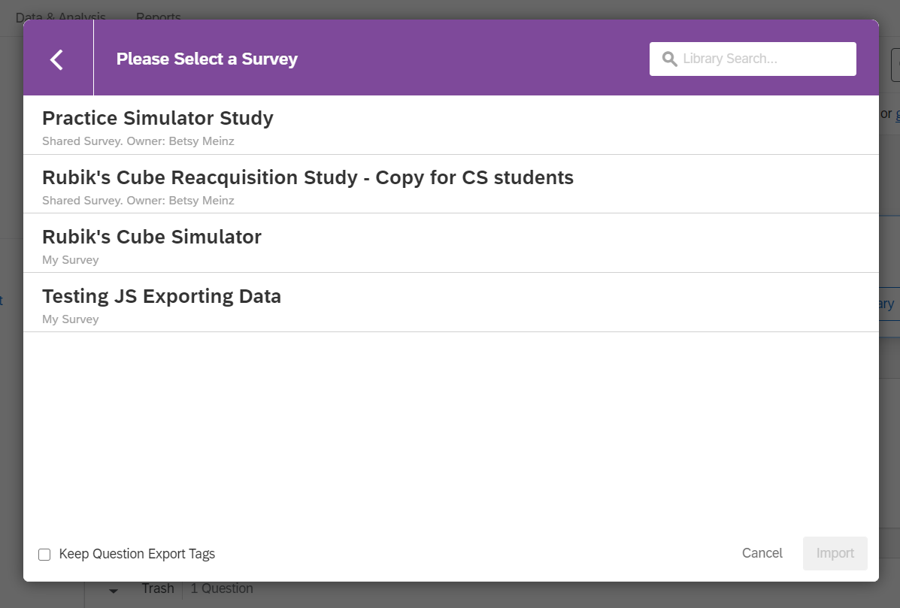

4. Select “Default Question Block” and click the green “Import x Questions” button. 